Ruth (Vaughn) Willey
April 26, 1896 – December 22, 1991

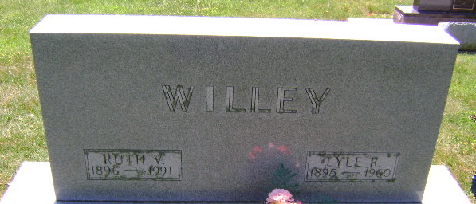
Photo by Bruce Sonner

Ruth Vaughan Willey
in the Indiana, U.S., Death Certificates, 1899-2017
Name Ruth Vaughan Willey
[Ruth Vaughan Vaughan]
Gender Female
Race White
Marital Status Widowed
Age 95
Birth Date 26 Apr 1896
Birth Place Morrow County, Ohio
Death Date 22 Dec 1991
Death Place Bluffton, Wells, Indiana, USA
Death Registration Date 1991
Father Walter Vaughan
Mother Mina Chase
Informant Richard Willey; son; Bluffton, Indiana
Burial December 24, 1991; Elm Grove Cemetery; Bluffton, Indiana

