Richard Vaughn Willey
November 6, 1921 – October 12, 2012

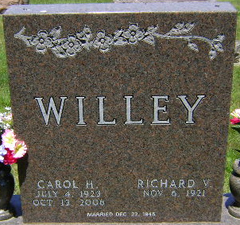
Photo by Bruce Sonner

Richard "Dick" Vaughn Willey, 90, of Bluffton passed away on Friday, October 12, 2012, at Bluffton Regional Medical Center. Dick was born on November 6, 1921, in Waterloo, Indiana to Lyle and Ruth (Vaughn) Willey. He graduated from Bluffton High School with the class of 1939, and went on to study at and play football for his beloved Purdue University.
After graduating from Purdue in 1943, he served in the United States Army in the 953rd Field Artillery Battalion. His unit landed at Omaha Beach following D-Day, fought across France and Germany, including the Battle of the Bulge, until the end of the hostilities in 1945.
After his service in the Army, during World War II, he was hired at Franklin Electric. He worked there as a supervisor and retired after 35 years of service. An avid golfer and gardener, he was also a member of the John Purdue Club, Parlor City Country Club and First United Methodist Church.
On December 22, 1946, he married Carol (Harvey) Willey. They were lifelong residents of Bluffton, and both were very active in the community. Together they raised four daughters and shared nearly 60 years of marriage before she preceded him in death on October 13, 2006.
He is survived by daughters Sylvia (Kenneth) Clark of Alexandria, Indiana; Sally (Douglas) Halberstadt of Bluffton, Indiana; Cynthia (Daniel) Leininger of Winona Lake, Indiana; and Sarah (Michael) Gotsch of South Bend, Indiana. He is also survived by 14 grandchildren and 13 great-grandchildren.
A memorial service will be held at 2:00 p.m. on Saturday, October 27, 2012, at the Thoma/Rich, Chaney & Lemler Funeral Home in Bluffton. Friends are invited to visit with the family from 12:00 noon to 2:00 p.m., prior to the service. The Rev. Greg Rittenhouse will officiate. Burial will follow at Elm Grove Cemetery in Bluffton. Military honors will be performed by the United States Army Honor Guard and the American Legion Post #111 Honor Guard.
In lieu of flowers, memorial contributions may be made in his memory to Bluffton High School Athletic Boosters for the benefit of the golf team or to the First United Methodist Church.

Thoma/Rich Funeral Home, Wells County, Indiana
October 13, 2012

