Lyle R. Willey
May 5, 1895 – February 9, 1960

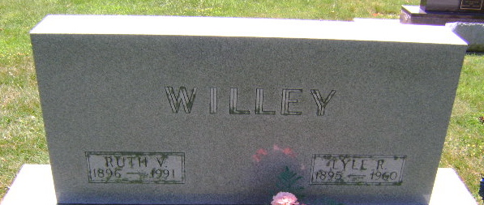
Photo by Bruce Sonner

Lyle R Willey
in the Indiana, U.S., Death Certificates, 1899-2017
Name Lyle R Willey
Gender Male
Race White
Marital Status Married
Age 64
Birth Date 5 May 1895
Birth Place Ohio
Death Date 9 Feb 1960
Death Place Bluffton, Wells, Indiana, USA
Death Registration Date 1960
Father James Willey
Mother Rose Snyder
Informant Mrs. Ruth Willey; wife; Bluffton, Indiana
Burial February 12, 1960; Elm Grove Cemetery; Bluffton, Indiana

