Mary Alice (Stotlar) Wilkinson
May 1, 1930 – March 14, 2009

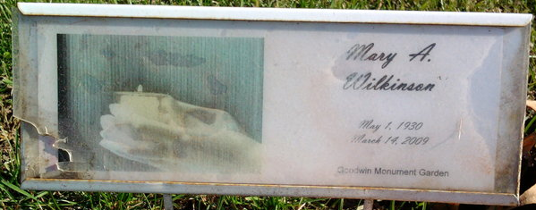
Photo by Thomas Liby

Mary Alice Stotler
in the Indiana, U.S., Birth Certificates, 1907-1944
Name Mary Alice Stotler
Gender Female
Birth Date 1 May 1930
Birth Place Liberty Center, Wells, Indiana, USA
Father Roy Stotler; age 27
Mother Goldie Culp; age 20; 1st child
Certificate Number 24464
Roll number 40474_356511
Volume Range 46 - 50
**
Indiana, U.S., Death Certificates, 1899-2017
Name Mary A Wilkinson
[Mary A Bundren]
Maiden Name Bundren
Gender Female
Race White
Marital Status Widowed
Age 78
Birth Date 1 May 1930
Birth Place Liberty Center, Indiana
Death Date 14 Mar 2009
Death Place Bluffton, Wells, Indiana, USA
Death Registration Date 2009
Father George Bundren
Mother Goldie Culp
Spouse Ronald Wilkinson; deceased
Informant Donald R. Goodwin; son; Bluffton, Indiana
Burial Elm Grove Cemetery; Bluffton, Indiana
**
Web: Indiana, U.S., Marion Public Library Marriage Index, 1831-2008
Name Mary A. Stollar
Gender Female
Marriage Date 6 Aug 1948
Marriage Place Grant, Indiana, USA
Spouse Donald Goodwin
**
Indiana, U.S., Marriage Certificates, 1960-2012
Name Mary A Goodwin
Gender Female
Marriage Age 37
Birth Date abt 1931
Birth Place Indiana
Marriage Date 16 Feb 1968
Marriage Place Bluffton, Wells, Indiana, USA
Spouse Ronald J Wilkinson
Notes 2 N
Reference Number 1 Bx1453
Reference Number 2 Tr8497
Certificate Number 68 005787
Box Number Box 4

