Dorothy W. (Webber) Wilkey
April 20, 1926 – September 8, 2010

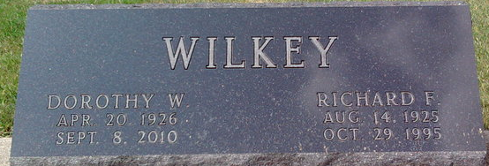
Photo by Thomas Liby

Dorothy W. "Dot" Wilkey, 84, of Bluffton passed away at 1:44 p.m. Wednesday, September 8, 2010 at River Terrace Estates. Born in Bluffton, Indiana, on April 20, 1926 to Justus Webber and Mary (Painter) Webber, she married Richard F. Wilkey in Bluffton, Indiana on June 29, 1947. Her husband preceded her in death on October 29, 1995.
Mrs. Wilkey graduated from Bluffton High School in 1944. She also graduated from Butler University and Purdue University earning a master’s degree. She was formerly a Guidance Counselor at Bluffton and Southern Wells High Schools. She was also a homemaker. She was a member of First Reformed Church in Bluffton.
Surviving relatives include three sons, John R. Wilkey (Ann) of Idaho, Frank J. Wilkey (Becky) of Idaho, and David A. Wilkey (Stephanie) of Virginia, four grandchildren; Andrea, Jackson, Jane, and Sarah, and the daughter that Dot always wanted, Mary McNamara Fogwell (Norm) of Bluffton and Mary's daughters, Leslie and Amanda. Dot was preceded in death by a brother, Justus R. "Bud" Webber.
Calling hours are 9:00 a.m. to 11:00 a.m. Thursday, September 16, 2010 at Thoma/Rich, Chaney & Lemler Funeral Home. Funeral services are 11:00 a.m. Thursday, September 16, 2010 at the funeral home with Dr. Gene Bell Officiating. Burial will be in Elm Grove Cemetery.
Preferred memorials are to the Wells County Foundation.

Thoma/Rich Funeral Home, Wells County, Indiana
September 9, 2010

