Wayne W. Wiley
April 22, 1915 – April 18, 2008

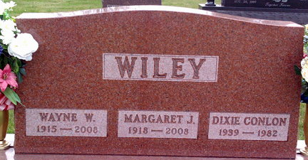
Photo by Thomas Liby

Bluffton native Wayne W. Wiley, 92, of Austintown, Ohio, died Friday, April 18, 2008. Born to Charles H. and Nellie B. (Allen) Wiley on April 22, 1915, in Bluffton, he married Margaret "Peg" (Jamison) Wiley on Aug. 23, 1938. She survives him.
He worked for 26 years with Hoosier Grain and Supply, and for 17 years with Central Soya Company in Indianapolis as a warehouse manager until he retired in 1977. He was a member of Canfield Christian Church, Bluffton Kiwanis, Moose Lodge and the Parlor City Country Club. He attained life member status with the Elks Lodge and Masonic Lodge #145 in Bluffton.
Other surviving relatives include one daughter, Vicki (Joel) Warner of Austintown; one sister, Mildred Reynolds of Bluffton; five grandchildren and two great-grandchildren.
Funeral services will be held Thursday at 10 a.m. at the Higgins-Reardon Funeral Home, Boardsman-Canfield Chapel in Canfield, Ohio. Visitation will be Wednesday from 7 p.m. to 9 p.m. at Higgins-Reardon Funeral Home and Friday from 7 p.m. to 9 p.m. at Thoma/Rich, Chaney & Lemler Funeral Home in Bluffton. A Masonic Memorial Service will be held at 7 p.m. Graveside services will be held Saturday at 10 a.m. at Elm Grove Cemetery in Bluffton. Pastor Larry Sprinkle will officiate.

Bluffton News-Banner, Wells County, Indiana
Monday, April 21, 2008

