Perry Oliver Wiley
October 16, 1869 – March 29, 1949

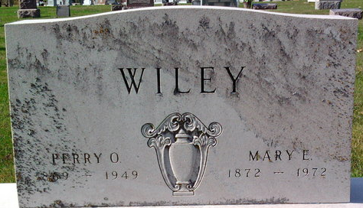
Photo by Thomas Liby

Oliver Perry WILEY from tree White Family Tree

Birth 16 Oct 1869 Wells, Indiana, USA
Marriage 1889
Residence 3 Apr 1930 Wells, Indiana, USA
Death 29 Mar 1949 Indianapolis, Marion, Indiana, USA
Father Robert W WILEY (1826-1910)
Mother Sarah (Sally) JONES (1834-1886)
Spouse Mary Emeline BRUMBAUGH (1872-1972)

