Nellie May (Allen) Wiley
August 3, 1881 – December 8, 1955

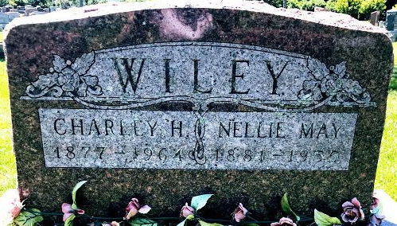
Photo by SMMR

Nellie May Wiley
in the Indiana, U.S., Death Certificates, 1899-2017
Name Nellie May Wiley
[Nellie May Allen]
Gender Female
Race White
Marital Status Married
Age 74
Birth Date 3 Aug 1881
Birth Place Indiana
Death Date 8 Dec 1955
Death Place Bluffton, Wells, Indiana, USA
Death Registration Date 1955
Father Alexander Allen
Mother Margaret Bryant
Informant Charles Wiley; same address
Burial December 10, 1955; Elm Grove Cemetery; Bluffton, Indiana

