Mary E. (Brumbaugh) Wiley
July 8, 1872 – November 10, 1972

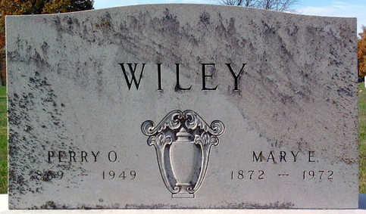
Photo by Thomas Liby

Mrs. Mary Wiley, 100, of Rolling Prairie, LaPorte County, died Friday at the Myers Nursing Home in Bremen. A resident of this county until 1930, she was born in 1872, a daughter of John and Amanda Brumbaugh. Her marriage was to Perry Wiley, whose death occurred in 1948.
Mrs. Wiley was a member of the United Methodist Church at Rolling Prairie.
Surviving is one son, Robert W. Wiley of LaPorte; one sister, Mrs. Cora Ankrom of Geneva; one brother, Homer Brumbaugh of Vicksburg, Michigan; four grandchildren and several great-grandchildren.
The body will be brought here to the Thoma Funeral Home, where services will be Monday; Rev. Robert Jackson officiating; burial in Elm Grove Cemetery.

Wells County, Indiana Obituaries
1969 – 1974

**
Indiana, U.S., Death Certificates, 1899-2017
Name Mary E Wiley
[Mary E Brumbaugh]
Gender Female
Race White
Age 100
Marital Status Widowed
Birth Date 8 Jul 1872
Birth Place Indiana
Death Date 10 Nov 1972
Death Place Bremen, Marshall, Indiana, USA
Death Registration Date 1972
Father: John Brumbaugh
Mother: Amanda
Informant: Robert Wiley; son; Laporte, Indiana
Burial: November 13, 1972; Elm Grove Cemetery; Bluffton, Indiana

