Margaret “Peg” (Jamison) Wiley
March 8, 1918 – July 2, 2008

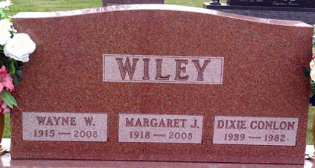
Photo by Thomas Liby

Margaret "Peg" Wiley, age 90, of Austintown, died Wednesday, July 2, 2008, at St. Elizabeth Hospital. She was born March 8, 1918 in Bridgeport, Ill., to Virtner and Nellie (Roberts) Jamison.
She was a member of Canfield Christian Church, the Parlor City Country Club, the Elks Lodge Ladies Auxiliary, and the Eastern Star in Bluffton.
She was preceded in death by her husband Wayne W. Wiley whom she married August 23, 1938. He died April 18, 2008. She is also preceded by a daughter, Dixie Lee Conlon, and a sister Audrey Johnson.
She is survived by a daughter, Vicki (Joel) Warner of Austintown; five grandchildren; two great grandchildren; two sisters Lou Bonnell and Kate Maus both of Robinson, Ill., and a brother Robert (Virginia) Jamison of Salem, Ill.
Calling will be Saturday from 4 to 6 p.m. at the Higgins-Reardon Funeral Home, Boardman-Canfield Chapel, in Canfield, Ohio, where the funeral service will be at 6 p.m. Friends may also call Monday from 7 to 9 p.m. at the Thoma/Rich, Chaney & Lemler Funeral Home in Bluffton. A graveside service will take place at 10 a.m. on Tuesday at Elm Grove Cemetery in Bluffton. Pastor Larry Sprinkle will officiate.

Bluffton News-Banner, Wells County, Indiana
Saturday, July 5, 2008

