Dixie Lee (Conlon) Wiley
August 25, 1939 – July 25, 1982

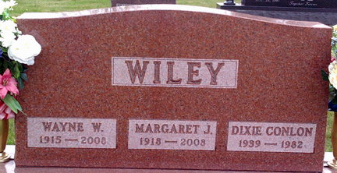
Photo by Thomas Liby

Dixie Lee Wiley
in the U.S., Social Security Applications and Claims Index, 1936-2007
Name Dixie Lee Wiley
[Dixie Lee Conlon]
[Dixie Conlon]
Gender Female
Race White
Birth Date 25 Aug 1939
Birth Place Bluffton Wel, Indiana
Death Date Jul 1982
Father Wayne Wiley
Mother Margaret Jamison
SSN xxx
Notes Aug 1956: Name listed as DIXIE LEE WILEY; Nov 1965: Name listed as DIXIE LEE CONLON; 05 Jan 1988: Name listed as DIXIE CONLON

**
Dixie Lee Wiley from tree Wadleigh Family Tree
Birth 25 Aug 1939 Bluffton, Wells, Indiana, USA
Residence 1940 Bluffton, Wells, Indiana, USA
Marriage 9 Oct 1965 Indianapolis, Marion, Indiana, USA
Death 25 Jul 1982
Father Wayne William Wiley (1915-2008)
Mother Margaret Josephine Jamison (1918-2008)

