Charles H. Wiley
February 15, 1877 – February 16, 1964

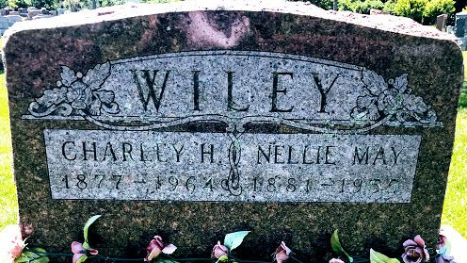
Photo by SMMR

Charles H Wiley
in the Indiana, U.S., Death Certificates, 1899-2017
Name Charles H Wiley
Gender Male
Race White
Marital Status Widowed
Age 87
Birth Date 15 Feb 1877
Birth Place Ridgeville, Indiana
Death Date 16 Feb 1964
Death Place Bluffton, Wells, Indiana, USA
Death Registration Date 1964
Father Andrew Wiley
Mother Racheal Collins
Informant Mrs. James Snider; daughter; Bluffton, Indiana
Burial February 19, 1964; Elm Grove Cemetery; Bluffton, Indiana

