William W. Wile, Jr.
January 31, 1908 – September 29, 1988

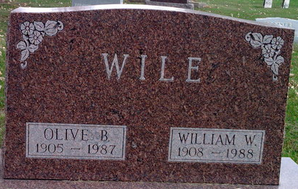
Photo by Bruce Sonner

William W Wile Jr
in the Indiana, U.S., Death Certificates, 1899-2017
Name William W Wile Jr
Gender Male
Race White
Marital Status Widowed
Age 80
Birth Date 31 Jan 1908
Birth Place Bluffton, Indiana
Death Date 29 Sep 1988
Death Place Bluffton, Wells, Indiana, USA
Death Registration Date 1988
Father William W Wile, Sr.
Mother Laura Sauvel
Informant William R. Wile; son; Bluffton, Indiana
Burial October 1, 1988; Elm Grove Cemetery; Bluffton, Indiana

