William Washington Wile
May 8, 1870 – September 15, 1947

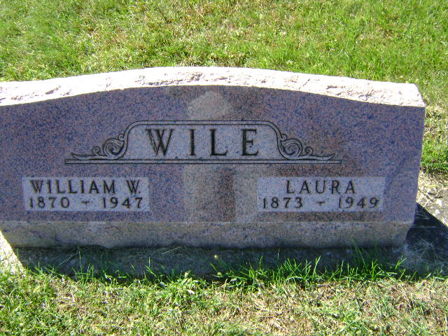
Photo by Bruce Sonner

Washington Wile
in the Indiana, U.S., Death Certificates, 1899-2017
Name William Washington Wile
Gender Male
Race White
Marital Status Married
Age 77
Birth Date 8 May 1870
Birth Place Wooster, Ohio
Death Date 15 Sep 1947
Death Place Bluffton, Wells, Indiana, USA
Death Registration Date 1947
Father Josie Wile
Mother Mary Samets
Spouse Laura Suvel; age 74
Informant Mrs. William W. Wile
Burial September 17, 1947; Elm Grove Cemetery; Bluffton, Indiana

