William Richard Wile
October 26, 1933 – April 3, 2020

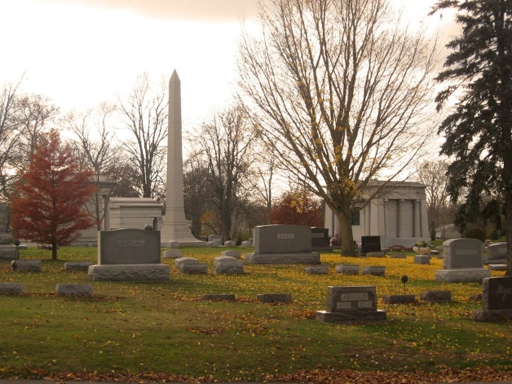
Photo by Tombstoner & Family

William “Bill” Richard Wile, 86 of Bluffton passed away on Friday morning, April 3,2020, at his residence. He was born on October 26, 1933 in Bluffton to William W. & Olive B. (Ulmer) Wile.
Bill graduated from Bluffton High School in 1951 and attended Ball State University and Indiana University School of Law. He served as the former Wells County Prosecuting Attorney, Legal Claims Manager at K & K Insurance Group in Fort Wayne and as the Legal Claims Manager for American Specialty Insurance Services in Roanoke, Indiana.
Bill served his country in the United State Navy from 1956 to 1957. He was a member of the First Reformed Church in Bluffton and a member of the Masonic Lodge # 145 F. & A. M. in Bluffton. He was a huge Chicago Cubs fan and was so thankful he could watch them win the World Series!
Bill and Sandra M. (Hoover) Wile were married on June 2, 1956 in New Castle, Indiana.
Survivors include his wife of 63 years Sandy of Bluffton and 3 children; Lori Wile, Julie Woodward and David Wile, all of Bluffton and numerous grandchildren and great-grandchildren in Indiana, Arizona and North Carolina.
There will be no services held at this time.
Memorials may be made in Bill’s memory to the American Heart Association or Wells County Council on Aging for the Wells on Wheels Program and can be mailed to the funeral home.

Thoma/Rich Funeral Home, Wells County, Indiana
April 4, 2020

