Olive B. (Ulmer) Wile
May 20, 1905 – October 19, 1987

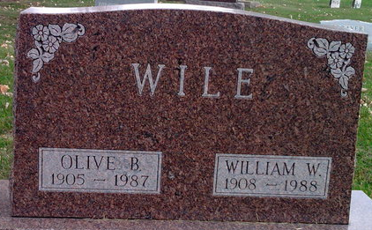
Photo by Bruce Sonner

Olive B Wile
in the Indiana, U.S., Death Certificates, 1899-2017
Name Olive B Wile
[Olive B Ulmer]
Gender Female
Race White
Marital Status Married
Age 82
Birth Date 20 May 1905
Birth Place Indiana
Death Date 19 Oct 1987
Death Place Bluffton, Wells, Indiana, USA
Death Registration Date 1987
Father Charles Ulmer
Mother Sarah Simeral
Spouse William W Wile Jr.
Informant William R. Wile; son; Bluffton, Indiana
Burial October 21, 1987; Elm Grove Cemetery; Bluffton, Indiana

