Laura (Sauvel) Wile
February 16, 1873 – December 2, 1949

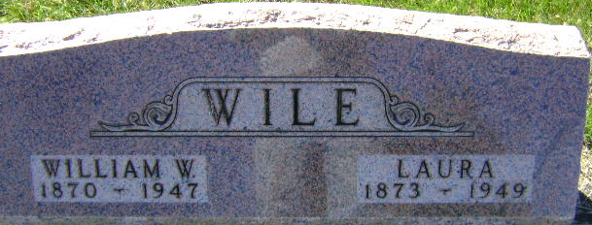
Photo by Bruce Sonner

Laura Wile
in the Indiana, U.S., Death Certificates, 1899-2017

Name Laura Wile
[Laura Sawvel]
Gender Female
Race White
Marital Status Widowed
Age 76
Birth Date 16 Feb 1873
Birth Place Indiana
Death Date 2 Dec 1949
Death Place Bluffton, Wells, Indiana, USA
Death Registration Date 1949
Father Issac Sawvel
Mother Mary
Informant Mr. W. Wile, Jr.; Bluffton, Indiana
Burial December 5, 1949; Elm Grove Cemetery; Bluffton, Indiana

