Peggy Sue Wildey
September 26, 1946 – September 26, 1946

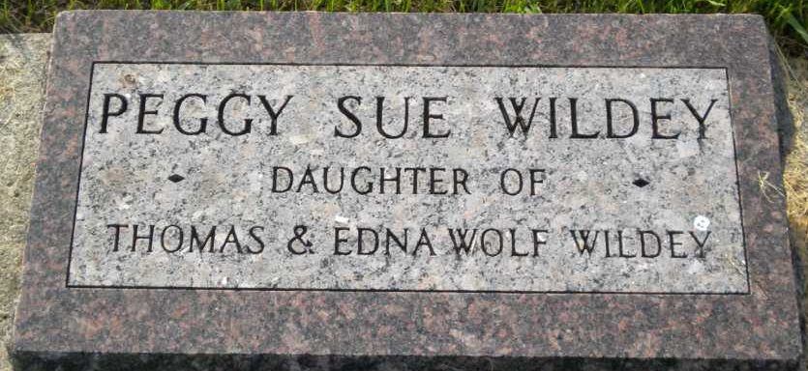
Photo by PLGS

Peggy Sue WILDEY from tree Ritchhart Family Tree_Sep 22
Birth 26 Sep 1946
Death 26 Sep 1946
Father Thomas A WILDEY (1922-1994)
Mother Edna WOLF (1922-2009)

