Robert W. Wietholter
April 28, 1939 – August 4, 2012

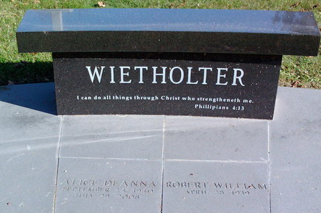
Photo by Thomas Liby

Robert "Bob" W. Wietholter,73, of Carmel, Indiana (formerly of Bluffton, IN) passed away on Saturday, August 4, 2012, at his residence in Carmel.
Bob was born on April 28, 1939 in Piqua, Ohio to William & Helen Carolina (Egbert) Wietholter. He graduated from Piqua Central High School in 1958 and studied business at Sinclair College in Dayton, Ohio.
On May 19, 1962, he married A. Deanna (Brumbaugh) Wietholter in Piqua. They shared 46 years together before she preceded him in death on July 29, 2008.
Bob, along with Deanna, owned and operated the Country Squire Florist in Bluffton from 1970 to 2001. His talent was professional floral design and commentator. He served as an American Floral Service Consultant in Design, Director of Floral Design at W.J. Cowee and a member of the American Institute of Floral Design including designing Christmas at the White House during the Ford Administration.
Bob was formerly a member of the First United Methodist Church in Bluffton and a member of St. Luke's United Methodist Church in Indianapolis, IN.
He is survived by two sons, W. Kyle (Carol Hauswald) Wietholter and J. Garrett (Lana Oman) Wietholter, both reside in Zionsville, Indiana, along with two grandchildren Michael W. & Eric L. Wietholter, and sisters; Mrs. Roger "Evelyn" Eymer of Bluffton, Mrs. Robert "Marcella" Puterbaugh of Tipp City, Ohio.
Calling hours will be held from 2 to 8 p.m. on Thursday, August 9, 2012, at the Thoma/Rich, Chaney & Lemler Funeral Home in Bluffton. Funeral Services will be held at 10:30 a.m. Friday, August 10, 2012, at the First United Methodist Church in Bluffton, where calling will take place for one hour prior to the service. The Rev. Marsha Hutchinson and Rev. Greg Rittenhouse will officiate. Burial will take place at Elm Grove Cemetery in Bluffton.
Memorials may be made to St. Luke's United Methodist Church Music Ministries in Memory of Robert Wietholter.
Thoma/Rich Funeral Home, Wells County, Indiana
August 5, 2012

