Alice Deanna (Brumbaugh) Wietholter
September 24, 1940 – July 29, 2008

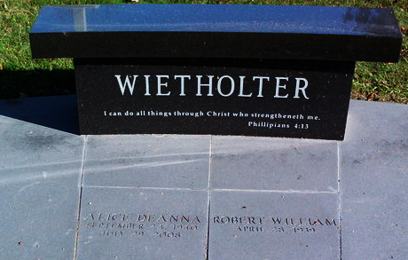
Photo by Thomas Liby

A. Deanna Wietholter, 67, of Westfield and formerly of Bluffton, died Tuesday afternoon, July 29, 2008, at St. Vincent's Hospital in Indianapolis.
Born in Piqua, Ohio on Sept. 24, 1940 to John A. and Helen Irene (Hildebrand) Brumbaugh, she married Robert "Bob" W. Wietholter in Piqua on May 19, 1962; he survives.
A 1958 graduate of Piqua Central High School, Mrs. Wietholter and her husband owned and operated Country Squire Florist in Bluffton from 1970 to 2001. She was also a homemaker and a member of St. Luke's United Methodist Church in Indianapolis. She was a former member of the First United Methodist Church in Bluffton.
Other surviving relatives include two sons, W. Kyle (Carol) Wietholter and J. Garrett (Lana) Wietholter, both of Zionsville: one sister, Rita (Jonathan) Laufman of Troy, Ohio; and two grandchildren. Mrs. Wietholter was preceded in death by one sister, Marilyn Brown.
Funeral services will be at 3 p.m. Sunday, at the First United Methodist Church in Bluffton with the Rev. Cindy Osgood and the Rev. Marsha Hutchinson officiating. Calling hours will be from 2 to 8 p.m. Saturday at the Thoma/Rich, Chaney & Lemler Funeral Home in Bluffton and for one hour prior to the service at the church. Burial is at Elm Grove Cemetery, in Bluffton.
Preferred memorials are to St. Luke's United Methodist Church in Indianapolis.

Bluffton News-Banner, Wells County, Indiana
Thursday, July 31, 2008

