William Ernst Wiecking
July 12, 1924 – November 13, 1944

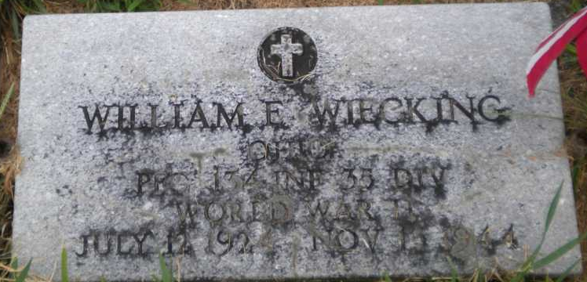
Photo by PLGS

William Ernst Wiecking
in the Indiana, U.S., Birth Certificates, 1907-1944
Name William Ernst Wiecking
Gender Male
Birth Date 12 Jul 1924
Birth Place Indianapolis, Marion, Indiana, USA
Father Wilbur Wiecking; age 29
Mother Audrey Normo; age 25
Certificate Number 38042
Roll number 40474_357288
Volume Range 76 - 80

**
U.S., Headstone Applications for Military Veterans, 1861-1985
Name William E Wiecking
Birth Date 12 Jul 1924
Service Number 35064341
Service Branch US Army Ground Forces
Unit 134 Inf. Regt A/S Inf
Company E
Enlistment Date 7 Jun 1943
Discharge Date 13 Nov 1944
Death Date 13 Nov 1944
Cemetery Elm Grove Cem
Cemetery Location Bluffton, Indiana, USA
**
U.S., Rosters of World War II Dead, 1939-1945
Name William E Wiecking
Gender Male
Race White
Religion Protestant
Cemetery Name Indiana
Disposition According to next of kin
Service Branch Army
Rank Private First Class
Service Number 35064341

