Wilbur Ernst Wiecking
February 1, 1895 – November 26, 1986

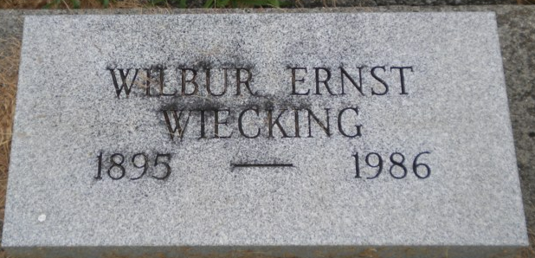
Photo by PLGS

Wilbur E Wiecking
in the Indiana, U.S., Death Certificates, 1899-2017
Name Wilbur E Wiecking
Gender Male
Race White
Marital Status Married
Age 91
Birth Date 1 Feb 1895
Birth Place Indiana
Death Date 26 Nov 1986
Death Place Berne, Adams, Indiana, USA
Death Registration Date 1986
Father Ernest Wiecking
Mother Not named
Spouse Iantha Weinland
Informant Iantha Wiecking; wife; Berne, Indiana
Burial November 29, 1986; Elm Grove Cemetery; Bluffton, Indiana

**
Wilbur E Wiecking in Normo and Gault Family Tree
Spouse Iantha A. Weinland
Father Ernst Friederich Wiecking
Mother Mary Catherine Studabaker
Children Kenneth David
Birth 1 Feb 1895 Indiana, USA
Death Nov 1986 Berne, Adams, Indiana, USA
Residence 1960 Parma, Cuyahoga, Ohio, USA

