Sara (Arnold) Wiecking
July 11, 1891 – April 28, 1961

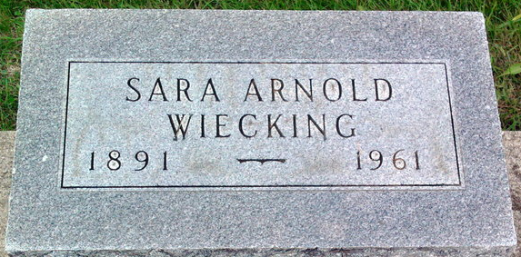
Photo by Thomas Liby

Sara A Wiecking
in the Indiana, U.S., Death Certificates, 1899-2017
Name Sara A Wiecking
[Sara A Arnold]
Gender Female
Race White
Marital Status Widowed
Age 68
Birth Date 11 Jul 1892(sic)
Birth Place Indiana
Death Date 28 Apr 1961
Death Place Bluffton, Wells, Indiana, USA
Death Registration Date 1961
Father Charles Arnold
Mother Sara Wall
Informant Hospital records
Burial April 30, 1961; Elm Grove Cemetery; Bluffton, Indiana

