Mary (Studabaker) Wiecking
August 10, 1860 – January 2, 1944

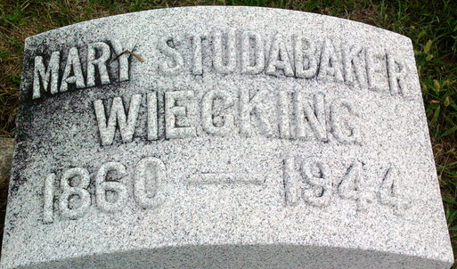
Photo by Thomas Liby

Mary Stanislaw Wiecking
in the Indiana, U.S., Death Certificates, 1899-2017
Name Mary Studabaker Wiecking
[Mary Studabaker]
Gender Female
Race White
Marital Status Widowed
Age 83
Birth Date 10 Aug 1860
Birth Place Adams County, Indiana
Death Date 2 Jan 1944
Death Place Bluffton, Wells, Indiana, USA
Death Registration Date 1944
Father Abram Studabaker
Mother Maria Stoops
Spouse Ernst Wiecking
Informant Herman Wiecking; Bluffton, Indiana
Burial January 4, 1944; Elm Grove Cemetery; Bluffton, Indiana

