Marie (White) Wiecking
September 26, 1897 – April 8, 1990

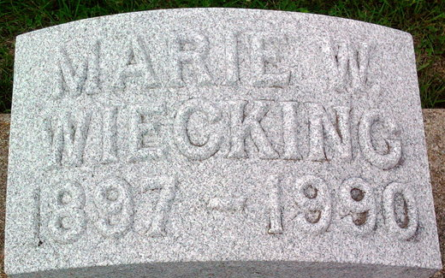
Photo by Thomas Liby

Marie W Wiecking
in the Indiana, U.S., Death Certificates, 1899-2017
Name Marie W Wiecking
[Marie W White]
Gender Female
Race White
Marital Status Widowed
Age 92
Birth Date 26 Sep 1897
Birth Place Evansville, Indiana
Death Date 8 Apr 1990
Death Place Greenwood, Johnson, Indiana, USA
Death Registration Date 1990
Father Charles P White
Mother Amelie Heseman
Informant Charles W. Wiecking; son; Bethesda, Maryland
Burial April 1 [sic - 11], 1990; Elm Grove Cemetery; Bluffton, Indiana

