Iantha Ann (Weinland) Wiecking
April 13, 1902 – April 26, 1988

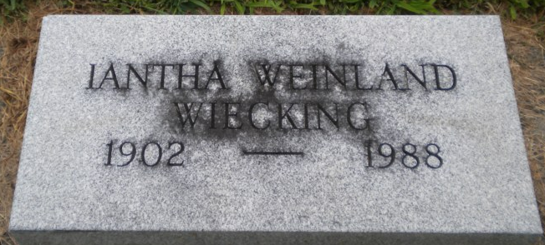
Photo by Thomas Liby

Iantha Ann Wiecking
in the Indiana, U.S., Death Certificates, 1899-2017
Name Iantha Ann Wiecking
Gender Female
Race White
Marital Status Widowed
Age 86
Birth Date 13 Apr 1902
Birth Place Wells County, Indiana
Death Date 26 Apr 1988
Death Place Berne, Adams, Indiana, USA
Death Registration Date 1988
Father William Weinland
Mother Winona Gavin
Informant Robert Weinland; brother; Portland, Indiana
Burial April 30, 1988; Elm Grove Cemetery; Bluffton, Indiana

