Herman Studabaker Wiecking
September 23, 1890 – June 17, 1953

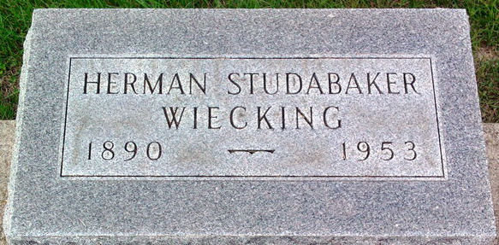
Photo by Thomas Liby

Herman Wiecking
in the Indiana, U.S., Death Certificates, 1899-2017
Name Herman Wiecking
Gender Male
Race White
Marital Status Married
Age 62
Birth Date 23 Sep 1890
Birth Place Bluffton, Indiana
Death Date 17 Jun 1953
Death Place Indianapolis, Marion, Indiana, USA
Death Registration Date 1953
Father Ernest Wiecking
Mother Mary Studabaker
Informant Herman Wiecking; Bluffton, Indiana
Burial June 19, 1953; Elm Grove Cemetery; Bluffton, Indiana

