Herman R. Wiecking
May 10, 1849 – June 5, 1915

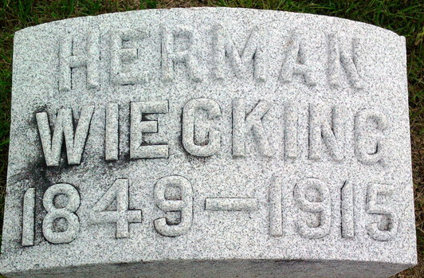
Photo by Thomas Liby

DIED SUDDENLY
Herman Wiecking, Well Known Bluffton Man
DIED IN NEW YORK
Had Been There Visiting Sister - Body May be Brought to Bluffton

Bluffton, Ind., June 7 – Herman Wiecking, unmarried, for years numbered among Bluffton's leading businessmen, died suddenly Saturday morning at Ridgeway, N. Y., where he had been visiting several months with a sister, Mrs. Charles Helmrich. A message received by his brother, Ernst Wiecking, of this city, gave no details as to the manner of death, but it is presumed he was a victim of heart trouble, from which he had been a sufferer.
Mr. Wiecking was born at Bramsche, Hanover, Germany, May 10, 1849, and came to the United States in 1866, first settling at Pittsburg. He came to Bluffton in 1875, and for years was in the tobacco and cigar business here, retail and wholesale. He retired from the active management of the business in 1903, since which time his brother, Ernst, has conducted the business. Mr. Wiecking became an extensive traveler after he retired from business and had visited Mexico several times, also had visited the Holy Land and every country of Europe, except Russia.
A number of brothers and sisters are the nearest surviving relatives.
Mr. Wiecking was a member of the local lodges of Elks and Odd Fellows. His brother, Ernst, left Saturday for Ridgeway, and may have the body brought here for burial.

Decatur Daily Democrat; Adams County, Indiana
Monday, June 7, 1915

