Frederick August Wiecking, Jr.
November 22, 1921 – July 14, 1963

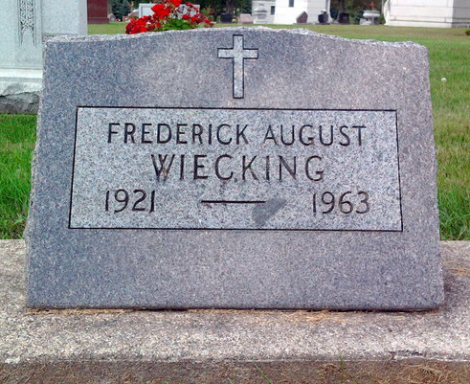
Photo by Thomas Liby

Indiana, U.S., Death Certificates, 1899-2017

Name Frederick August Wiecking
Gender Male
Race White
Marital Status Married
Age 41y 7m 22d
Military WW II
Birth Date 22 Nov 1921
Birth Place Bluffton, Indiana
Death Date 14 Jul 1963
Death Place Bluffton, Wells, Indiana, USA
Death Registration Date 1963
Father Fred A Wiecking Sr.
Mother Marie White
Spouse Kitty Lou Wiecking, informant
Burial 7-16-1963 Elm Grove Cemetery

