Frederick A. “Dutch” Wiecking
August 15, 1892 – July 28, 1936

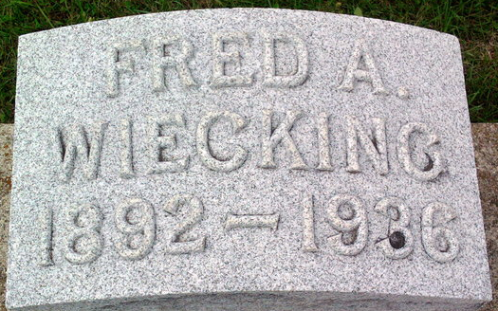
Photo by Thomas Liby

Fred A Wiecking
in the Indiana, U.S., Death Certificates, 1899-2017
Name Fred A Wiecking
Gender Male
Race White
Marital Status Married
Age 43
Birth Date 15 Aug 1892
Birth Place Bluffton, Indiana
Death Date 28 Jul 1936
Death Place Indianapolis, Marion, Indiana, USA
Death Registration Date 1936
Father Ernst Wiecking
Mother Mary Studabaker
Spouse Marie
Informant Wilbur E. Wiecking; Cleveland, Ohio
Burial July 31, 1936; Bluffton, Indiana

