Ernst Wiecking
December 5, 1858 – October 23, 1934

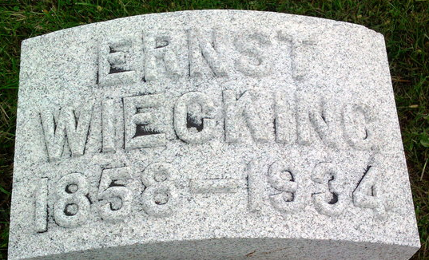
Photo by Thomas Liby

Ernst Wiecking
in the Indiana, U.S., Death Certificates, 1899-2017
Name Ernst Wiecking
Gender Male
Race White
Marital Status Married
Age 75
Birth Date 5 Dec 1858
Birth Place Germany
Death Date 23 Oct 1934
Death Place Bluffton, Wells, Indiana, USA
Death Registration Date 1934
Father Rudolph Wiecking
Mother Hernine Meyran
Spouse Mary Studebaker
Informant Fred Wiecking; Indianapolis, Indiana
Burial October 25, 1934; Elm Grove Cemetery

