Catherine L. (Barth) Wiecking
December 8, 1923 – August 3, 1992

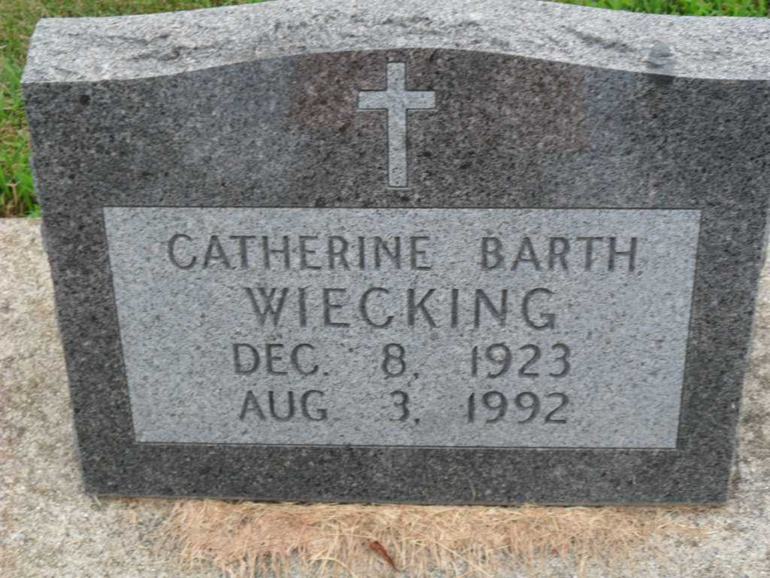
Photo by PLGS

Catherine Wiecking
in the Indiana, U.S., Death Certificates, 1899-2017
Name Catherine Wiecking
[Catherine Barth]
Gender Female
Race White
Marital Status Widowed
Age 68
Birth Date 8 Dec 1923
Birth Place Essex County, New York
Death Date 3 Aug 1992
Death Place Indianapolis, Marion, Indiana, USA
Death Registration Date 1992
Father Charles Herbert Barth
Mother Helen Armfield
Informant Helen King; daughter; San Martin, California
Cremation August 6, 1992; Indianapolis Crematory; Indianapolis, Indiana

