Audrey (Normo) Wiecking
July 2, 1899 – April 16, 1961

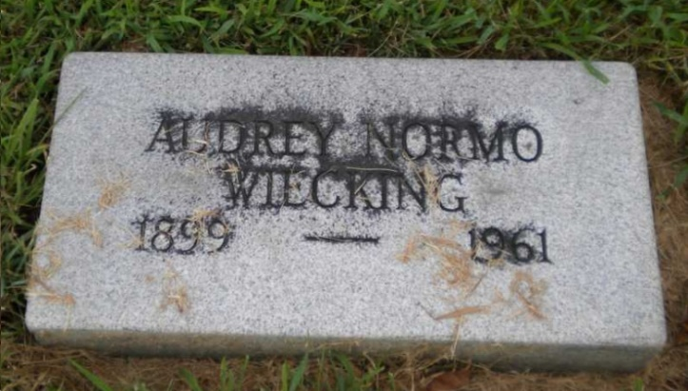
Photo by PLGS

Audrey A Wiecking
in the Ohio, U.S., Death Records, 1908-1932, 1938-2022

Name Audrey A Wiecking
Gender Female
Race White
Marital Status Married
Death Age 61
Birth Date Abt 1900
Residence Place Parma Heights, Cuyahoga, Ohio, USA
Death Date 19 Apr 1961
Death Place Cleveland, Cuyahoga, Ohio, USA
Certificate Number 24276
Inquest Hospital Deaconess Hosp. of Cleveland
Inquest Questions Certifier: Physician; Autopsy Performed?: Yes, Not Used For Certification;
**
Asbjorg Kjaer from tree MetcalfWareAdamsThomas New Version
Birth 2 Jul 1899 Tromsø, Troms, Norway
Residence 1900 Tromsø, Troms, Norway
Marriage 1926
Death 19 Apr 1961 Parma, Cuyahoga, Ohio, USA
Father Jørgen Mathias Hansen Kjær Normo (1863-1945)
Mother Berntine Gunelie Bensen (1870-1946)
Spouse Wilbur Ernst Wiecking (1895-1986)

