Lewis Everett Wibel
January 11, 1882 – October 3, 1965

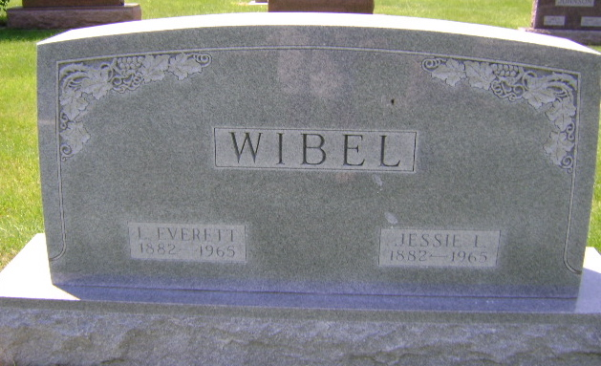
Photo by Bruce Sonner

Lewis E Wible
in the Indiana, U.S., Death Certificates, 1899-2017
Name Lewis E Wible
Gender Male
Race White
Marital Status Widowed
Age 83
Birth Date 11 Jan 1882
Birth Place Indiana
Death Date 3 Oct 1965
Death Place Bluffton, Wells, Indiana, USA
Death Registration Date 1965
Father John L Wible
Mother Margaret Mills
Informant Kathryn Ashbaucher; daughter; Indianapolis, Indiana
Burial October 6, 1965; Elm Grove Cemetery; Bluffton, Indiana

