Jessie L. (Petty) Wibel
August 19, 1882 – October 3, 1965

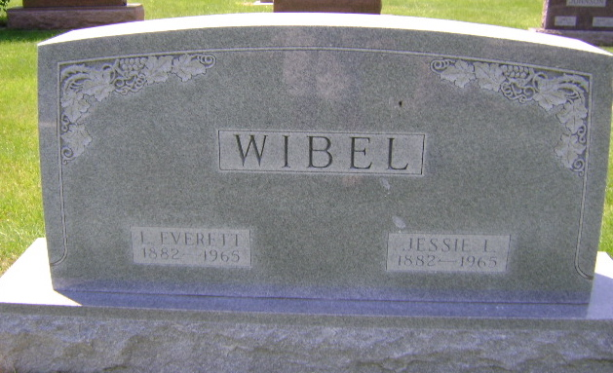
Photo by Bruce Sonner

Jessie L Wible
in the Indiana, U.S., Death Certificates, 1899-2017

Name Jessie L Wible
[Jessie L Petty]
Gender Female
Race White
Marital Status Married
Age 83
Birth Date 19 Aug 1882
Birth Place Indiana
Death Date 3 Oct 1965; auto accident
Death Place Bluffton, Wells, Indiana, USA
Death Registration Date 1965
Father David Petty
Mother Martha Young
Informant Marie Ponder; sister; Indianapolis, Indiana
Burial October 6, 1965; Elm Grove Cemetery; Bluffton, Indiana

