Emma D. (Garton) Wibel
January 26, 1882 – October 3, 1975

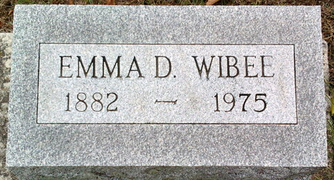
Photo by Thomas Liby

Emma Wibel
in the Indiana, U.S., Death Certificates, 1899-2017
Name Emma Wibel
[Emma Garton]
Gender Female
Race White
Marital Status Widowed
Age 93
Birth Date 26 Jan 1882
Birth Place Indiana
Death Date 3 Oct 1975
Death Place Bluffton, Wells, Indiana, USA
Death Registration Date 1975
Father Marion Garton
Mother Nancy Wilkin
Informant Mrs. Fred (Kathryn) Ashbaucher; daughter; Indianapolis, Indiana
Burial October 6, 1975; Elm Grove Cemetery; Bluffton, Indiana

