Mary Helen (Wile) Whitman
June 29, 1901 – August 15, 1944

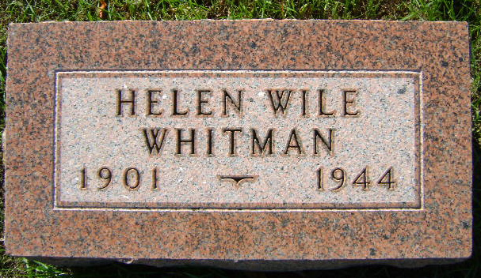
Photo by Bruce Sonner

Mary Helen Wile Whitman
in the Indiana, U.S., Death Certificates, 1899-2017

Name Mary Helen Wile Whitman
[Mary Helen Wile Wile]
Gender Female
Race White
Marital Status Married
Age 43
Birth Date 29 Jun 1901
Birth Place Bluffton, Indiana
Death Date 15 Aug 1944
Death Place Bluffton, Wells, Indiana, USA
Death Registration Date 1944
Father Wm W Wile, Sr.
Mother Laura Sawvel
Spouse Ernest J Whitman; age 44
Informant Wm. W. Wile, Sr.; Bluffton, Indiana
Burial August 17, 1944; Elm Grove Cemetery; Bluffton, Indiana

