William Talmage White
July 7, 1885 – November 21, 1968

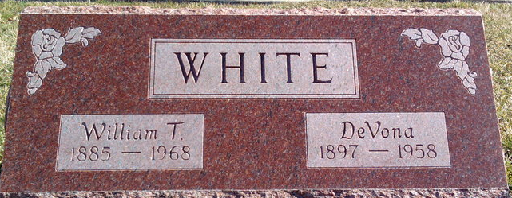
Photo by Thomas Liby

William Talmage White
in the Indiana, U.S., Death Certificates, 1899-2017
Name William Talmage White
Gender Male
Race White
Marital Status Married
Age 83
Birth Date 7 Jul 1885
Birth Place Indiana
Death Date 21 Nov 1968
Death Place Bluffton, Wells, Indiana, USA
Death Registration Date 1968
Father Vincent White
Mother Olive Priest
Spouse Rachel Bay Gaunt
Informant Mrs. Rachel White; wife; Bluffton, Indiana
Burial November 23, 1968; Elm Grove Cemetery; Bluffton, Indiana

