Rachel R. (Bay) White
July 10, 1909- August 24, 1992

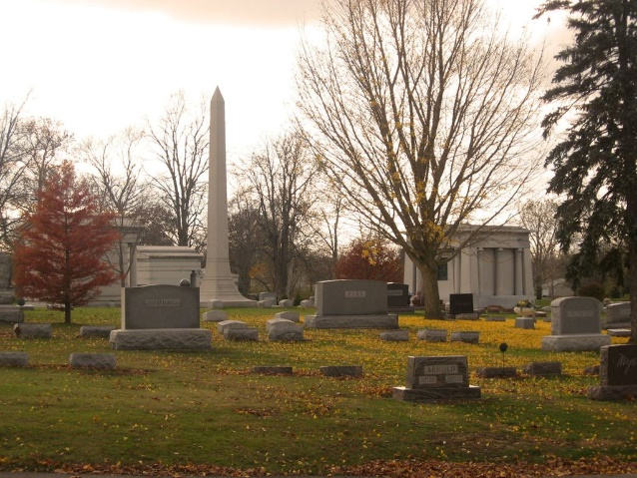
Photo by Tombstoner & Family

Rochel R White
in the Indiana, U.S., Death Certificates, 1899-2017
Name Rachel R White
[Rachel R Boy]
Gender Female
Race White
Marital Status Widowed
Age 83
Birth Date 10 Jul 1909
Birth Place Liberty Center, Indiana
Death Date 24 Aug 1992
Death Place Bluffton, Wells, Indiana, USA
Death Registration Date 1992
Father Edward Bay
Mother Estelle Moore
Spouse W Thomas White; deceased
Informant Larry Gaunt; son; Bluffton, Indiana
Burial August 26, 1992; Elm Grove Cemetery; Bluffton, Indiana

