Maxine Lelia (Bergdoll) White
January 1, 1902 – October 12, 1950

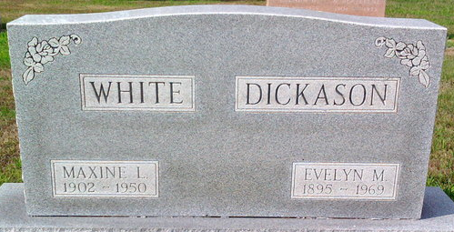
Photo by Thomas Liby

Mrs Macine Lalia White
in the Texas, U.S., Death Certificates, 1903-1982
Name Mrs Maxine Lelia White
[Mrs Maxine Lelia Bergdall]
Gender Female
Race White
Death Age 39
Birth Date 1 Jan 1911 [sic]
Birth Place Wells County, Indiana
Residence Date Abt 1950
Residence Place Houston, Harris, Texas, USA
Death Date 12 Oct 1950
Death Place Houston, Harris, Texas, USA
Father Bergdall
Mother Julia Connette
Informant Can't read
Removal October 13, 1950; Bluffton, Indiana

