Marjorie Brooks White
November 5, 1916 – October 25, 1917

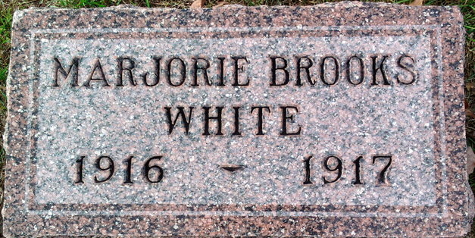
Photo by Thomas Liby

Marjorie Brooks White
in the Indiana, U.S., Death Certificates, 1899-2017
Name Marjorie Brooks White
Gender Female
Race White
Marital Status Single
Age 11 months, 20 days
Birth Date 5 Nov 1916
Birth Place Bluffton, Indiana
Death Date 25 Oct 1917
Death Place Bluffton, Wells, Indiana, USA
Death Registration Date 1917
Father Guy White
Mother Nilla Nave
Informant Ferd White; Bluffton, Indiana
Burial October 28, 1917; Elm Grove Cemetery

