Lester P. White
September 15, 1895 – October 5, 1956

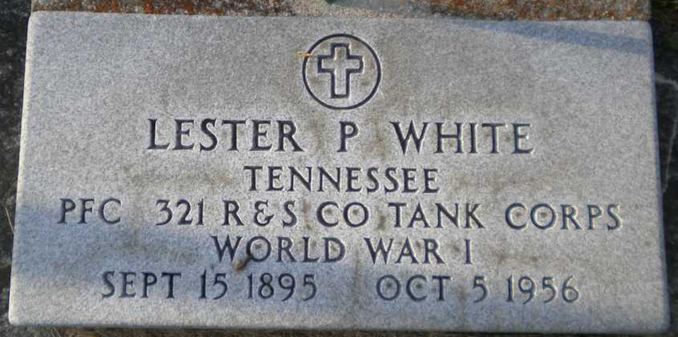
Photo by PLGS

Lester P. White
in the U.S., Headstone Applications for Military Veterans, 1861-1985
Name Lester P. White
Rank Private 1st Class
Birth Date 15 Sep 1895
Service Number 3 359 003
Service Branch US Army
Unit 321st Repair and Service Co. 1 Tank Brig
Enlistment Date 29 May 1918
Discharge Date 20 Mar 1919
Death Date 5 Oct 1956
Cemetery Elem Grove
Cemetery Location Bluffton, Indiana, USA
Applicant Mrs. Evelyn Dick; May 5, 1962

