Josephine (Harbaugh) White
March 9, 1856 – July 11, 1935

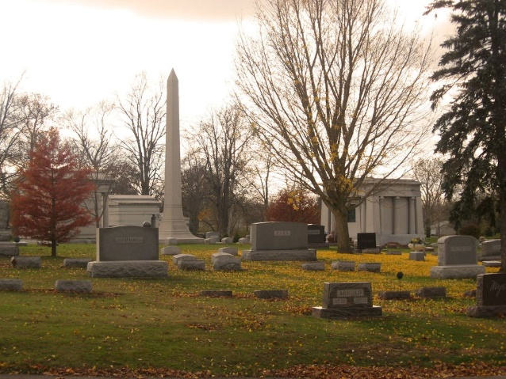
Photo by Tombstoner & Family

Josephine Harbaugh White
in the Indiana, U.S., Death Certificates, 1899-2017
Name Josephine Harbaugh White
[Josephine Harbaugh Harbaugh]
Gender Female
Race White
Marital Status Widowed
Age 79
Birth Date 9 Mar 1856
Birth Place Indiana
Death Date 11 Jul 1935
Death Place Bluffton, Wells, Indiana, USA
Death Registration Date 1935
Father Wm Harbaugh
Mother Nancy Poffenberger
Spouse Fernando White
Informant Guy White; Bluffton, Indiana
Burial July 13, 1935; Elm Grove Cemetery

