Jay Edward White
March 10, 1887 – June 3, 1956

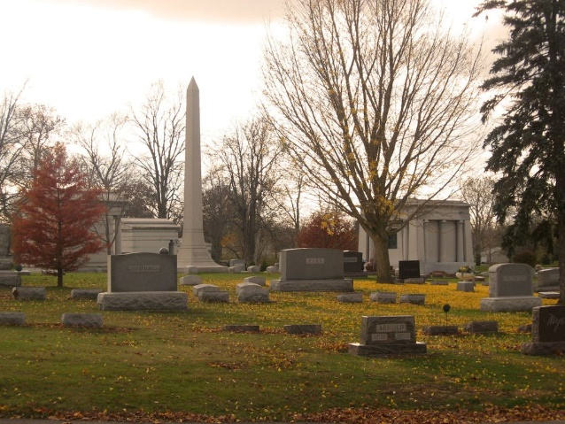
Photo by Tombstoner & Family

Jay Edward White from tree Poffenburger Family Tree
Birth 10 Mar 1887 Bluffton, Wells, Indiana, USA
Residence 1900 Bluffton, Wells, Indiana, USA
Death 3 Jun 1956
Father Ferdinando White (1855-1933)
Mother Josephine Harbaugh (1856-1935)

