Guy L. White
January 17, 1891 – March 8, 1962

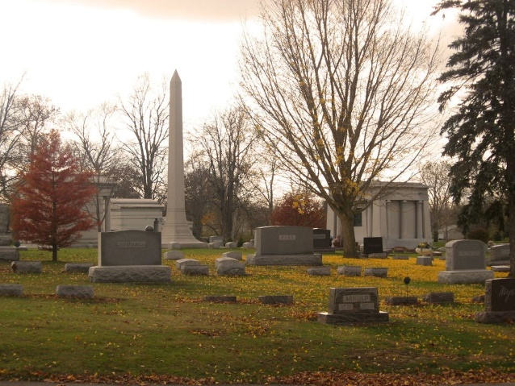
Photo by Tombstoner & Family

Guy L White
in the Indiana, U.S., Death Certificates, 1899-2017
Name Guy L White
Gender Male
Race White
Marital Status Widowed
Age 71
Birth Date 17 Jan 1891
Birth Place Bluffton, Indiana
Death Date 8 Mar 1962
Death Place Bluffton, Wells, Indiana, USA
Death Registration Date 1962
Father Fernando White
Mother Josephine Harbaugh
Informant Wendell White; son; Bluffton, Indiana
Burial March 10, 1962; Elm Grove Cemetery; Bluffton, Indiana

