Fernando White
October 11, 1856 – April 9, 1933

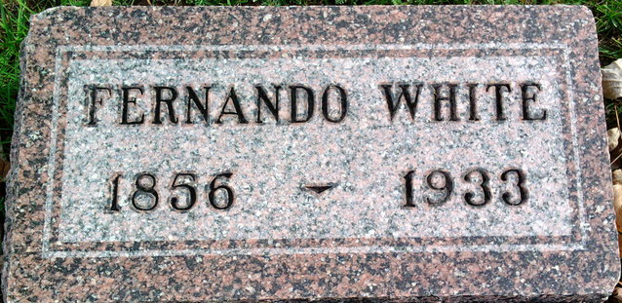
Photo by Thomas Liby

Fernando White
in the Indiana, U.S., Death Certificates, 1899-2017
Name Fernando White
Gender Male
Race White
Marital Status Married
Age 76
Birth Date 11 Oct 1856
Birth Place Bluffton, Indiana
Death Date 9 Apr 1933
Death Place Bluffton, Wells, Indiana, USA
Death Registration Date 1933
Father Jackson E. White
Mother Graves
Spouse Josephine Harbaugh
Informant Josephine White; Bluffton, Indiana
Burial April 11, 1933; Fairview Cemetery; Bluffton, Indiana(sic)

