Charles W. White
March 6, 1945 – April 2, 1945

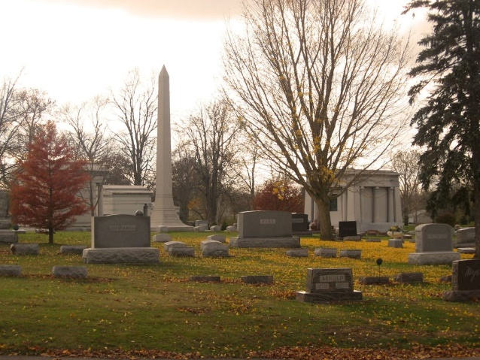
Photo by Tombstoner & Family

Charles W White
in the Indiana, U.S., Death Certificates, 1899-2017
Name Charles W White
Gender Male
Race White
Marital Status Single
Age 1/12
Birth Date 6 Mar 1945
Birth Place Wells County
Death Date 2 Apr 1945
Death Place Bluffton, Wells, Indiana, USA
Death Registration Date 1945
Father Wendel White
Mother Madge Blodgett
Informant Wendel White; Bluffton, Indiana
Burial April 4, 1945; Elm Grove Cemetery; Bluffton, Indiana

