Bertha DeVona (Church) White
February 23, 1897 – February 28, 1958

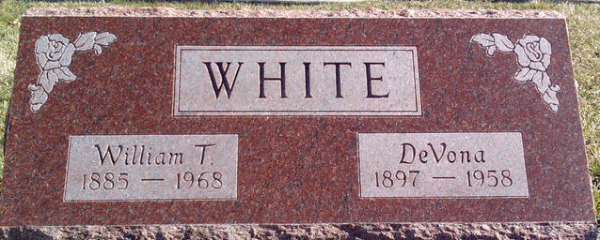
Photo by Thomas Liby

Bertha De Vona White
in the Indiana, U.S., Death Certificates, 1899-2017
Name Bertha De Vona White
[Bertha De Vona Church]
Gender Female
Race White
Marital Status Married
Age 61
Birth Date 23 Feb 1897
Birth Place Wells County, Indiana
Death Date 28 Feb 1958
Death Place Bluffton, Wells, Indiana, USA
Death Registration Date 1958
Father Spafford Church
Mother Mary Etta Gilliand
Informant W.T. White; husband; Bluffton, Indiana
Burial March 2, 1958; Elm Grove Cemetery; Bluffton, Indiana

