Betty L. (Stout) Wham
July 23, 1919 – July 8, 1967

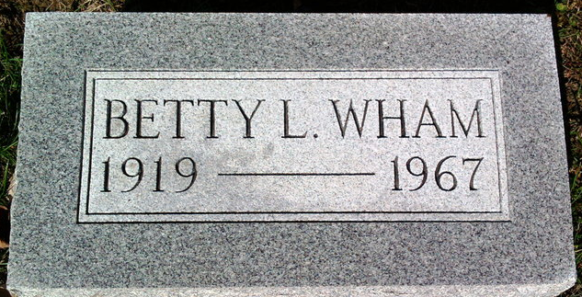
Photo by Thomas Liby

Betty L Wham
in the Indiana, U.S., Death Certificates, 1899-2017
Name Betty L Wham
[Betty L Stout]
Gender Female
Race White
Marital Status Married
Age 47
Birth Date 23 Jul 1919
Birth Place Indiana
Death Date 8 Jul 1967
Death Place Marion, Grant, Indiana, USA
Death Registration Date 1967
Father Munson Stout
Mother Ruth Brinneman Marshal
Informant Richard H Wham; husband; Marion, Indiana
Burial July 10, 1967; Elm Grove Cemetery; Bluffton, Indiana

