Winifred E. (Myers) Weterick
March 24, 1920 – December 14, 2010

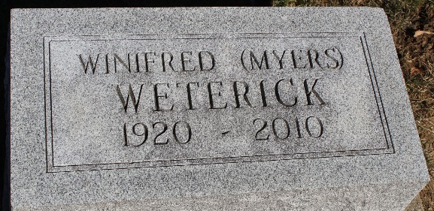
Photo by Tombstoner & Family

Winifred E. Weterick, 90, a resident of the Christian Care Retirement Community in Bluffton, died there at 1:40 a.m. Tuesday, Dec. 14, 2010.
Mrs. Weterick was a homemaker and was a member of First Reformed Church and the Psi Iota Xi sorority, and also was a librarian's aide at the Poplar Grove School. She also volunteered many hours at the Caylor-Nickel Clinic and assisted at the gift shop there. She was a 1938 graduate of Chester Center School.
She was born March 24, 1920, in Wells County, to Cleophas E. Myers and Marie Risley Myers. She married Charles R. Weterick in Bluffton July 5, 1945; her husband died Feb. 19, 1999.
Survivors include a daughter, Cheryl (Jesse) Combs of Decatur; two sons, Jon (Sue) Weterick of Fort Wayne and Joe (Barbara) Weterick of Bluffton; two grandchildren, Kaylyn Weterick of Bluffton and Kurt Combs of Monroe; two great-grandchildren, Dalton Combs and Kyleigh Combs, both of Monroe; a sister, Lucille Levy of Bluffton; and a sister-in-law, Sandra Myers of Bluffton.
In addition to her parents and her husband, she was preceded in death by a sister, Betty Myers; a brother, Herman Myers; and a great-grandchild, Kyle Andrew Combs.
Calling will be from 2 to 8 p.m. Thursday, Dec. 16, at the Thoma/Rich, Cheney and Lemler Funeral Home in Bluffton. Services will be held at 11 a.m. Friday at the funeral home with Dr. Bryson E. Bell officiating. Burial will be at the Elm Grove Cemetery.
Preferred memorials are to First Reformed Church or the Christian Care Retirement Community.

Thoma/Rich Funeral Home, Wells County, Indiana
December 15, 2010

